

**SCHOOL OF COMPUTER SCIENCE ENGINEERING**

**AND INFORMATION SYSTEMS**

**WINTER SEMESTER 2024-2025**

**PMCA504L – SOFTWARE ENGINEERING**

**DIGITAL ASSIGNMENT**

**SUBMITTED ON: 10 – APR - 2025**

**SUBMITTED BY-**

**AKASH KUMAR BANIK [24MCA0242]**

**RAHUL MITTAL [24MCA0252]**

**KARAN MAURYA [24MCA0260]**

**Q1. Draw state machine models of the control software for: An automatic washing machine which has different programs for different types of clothes.**

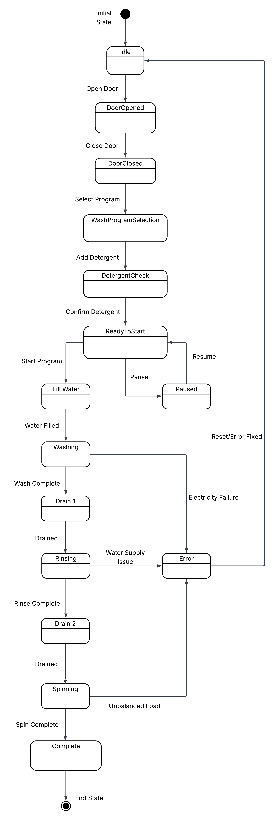

**Explanation:**

1. **Initial State – Idle**

* The washing machine begins in the **Idle** state, which represents the default condition when the machine is powered on or reset.

1. **Door Handling**

* From the **Idle** state, the user can open the machine door, transitioning the system to the **DoorOpen** state (where the user puts clothes in the machine).
* After the door is open, closing it moves the system to the **DoorClosed** state.

1. **Wash Program Selection Phase**

* Once the door is closed, the user may select a desired washing program (such as cotton, wool, or delicate).
* After selecting the program, the user is prompted to add detergent.
* When detergent has been added and confirmed, the system becomes ready to start the wash cycle.

1. **Washing Cycle Execution**

* The washing cycle begins when the user starts the program, transitioning to the **WaterFill** state.
* Once the water is filled, the system proceeds to **Washing** state.
* After the wash cycle completes, the water is drained (Drain-1), followed by a rinsing phase which transitions the machine to the **Rinsing** state.
* Once rinsing is complete, the water is again drained (Drain-2), after which the system transitions to the **Spinning** state.
* After spinning is complete, the machine moves to the **Complete** state which indicates that the washing process is complete.
* Finally, the machine proceeds to the **End** state.

1. **Pause and Resume Functionality**

* The user also has the option to pause the machine before or during the start of the program from **ReadyToStart** state.
* The process can be resumed from the paused state, offering flexibility and control.

1. **Error Handling**

* The system includes comprehensive error detection at key stages, ensuring robust operation. Specific failure points and their transitions to the Error state are as follows:

|  |  |
| --- | --- |
| **Component** | **Error Transition** |
| Washing | Washing → Error: Electricity Failure |
| Rinsing | Rinsing → Error: Water Supply Issue |
| Spinning | Spinning → Error: Unbalanced Load |

* Once the issue is resolved or reset by the user, the system returns to the **Idle** state.

**Q2. Draw state machine models of the control software for: The software for a compact disc player.**

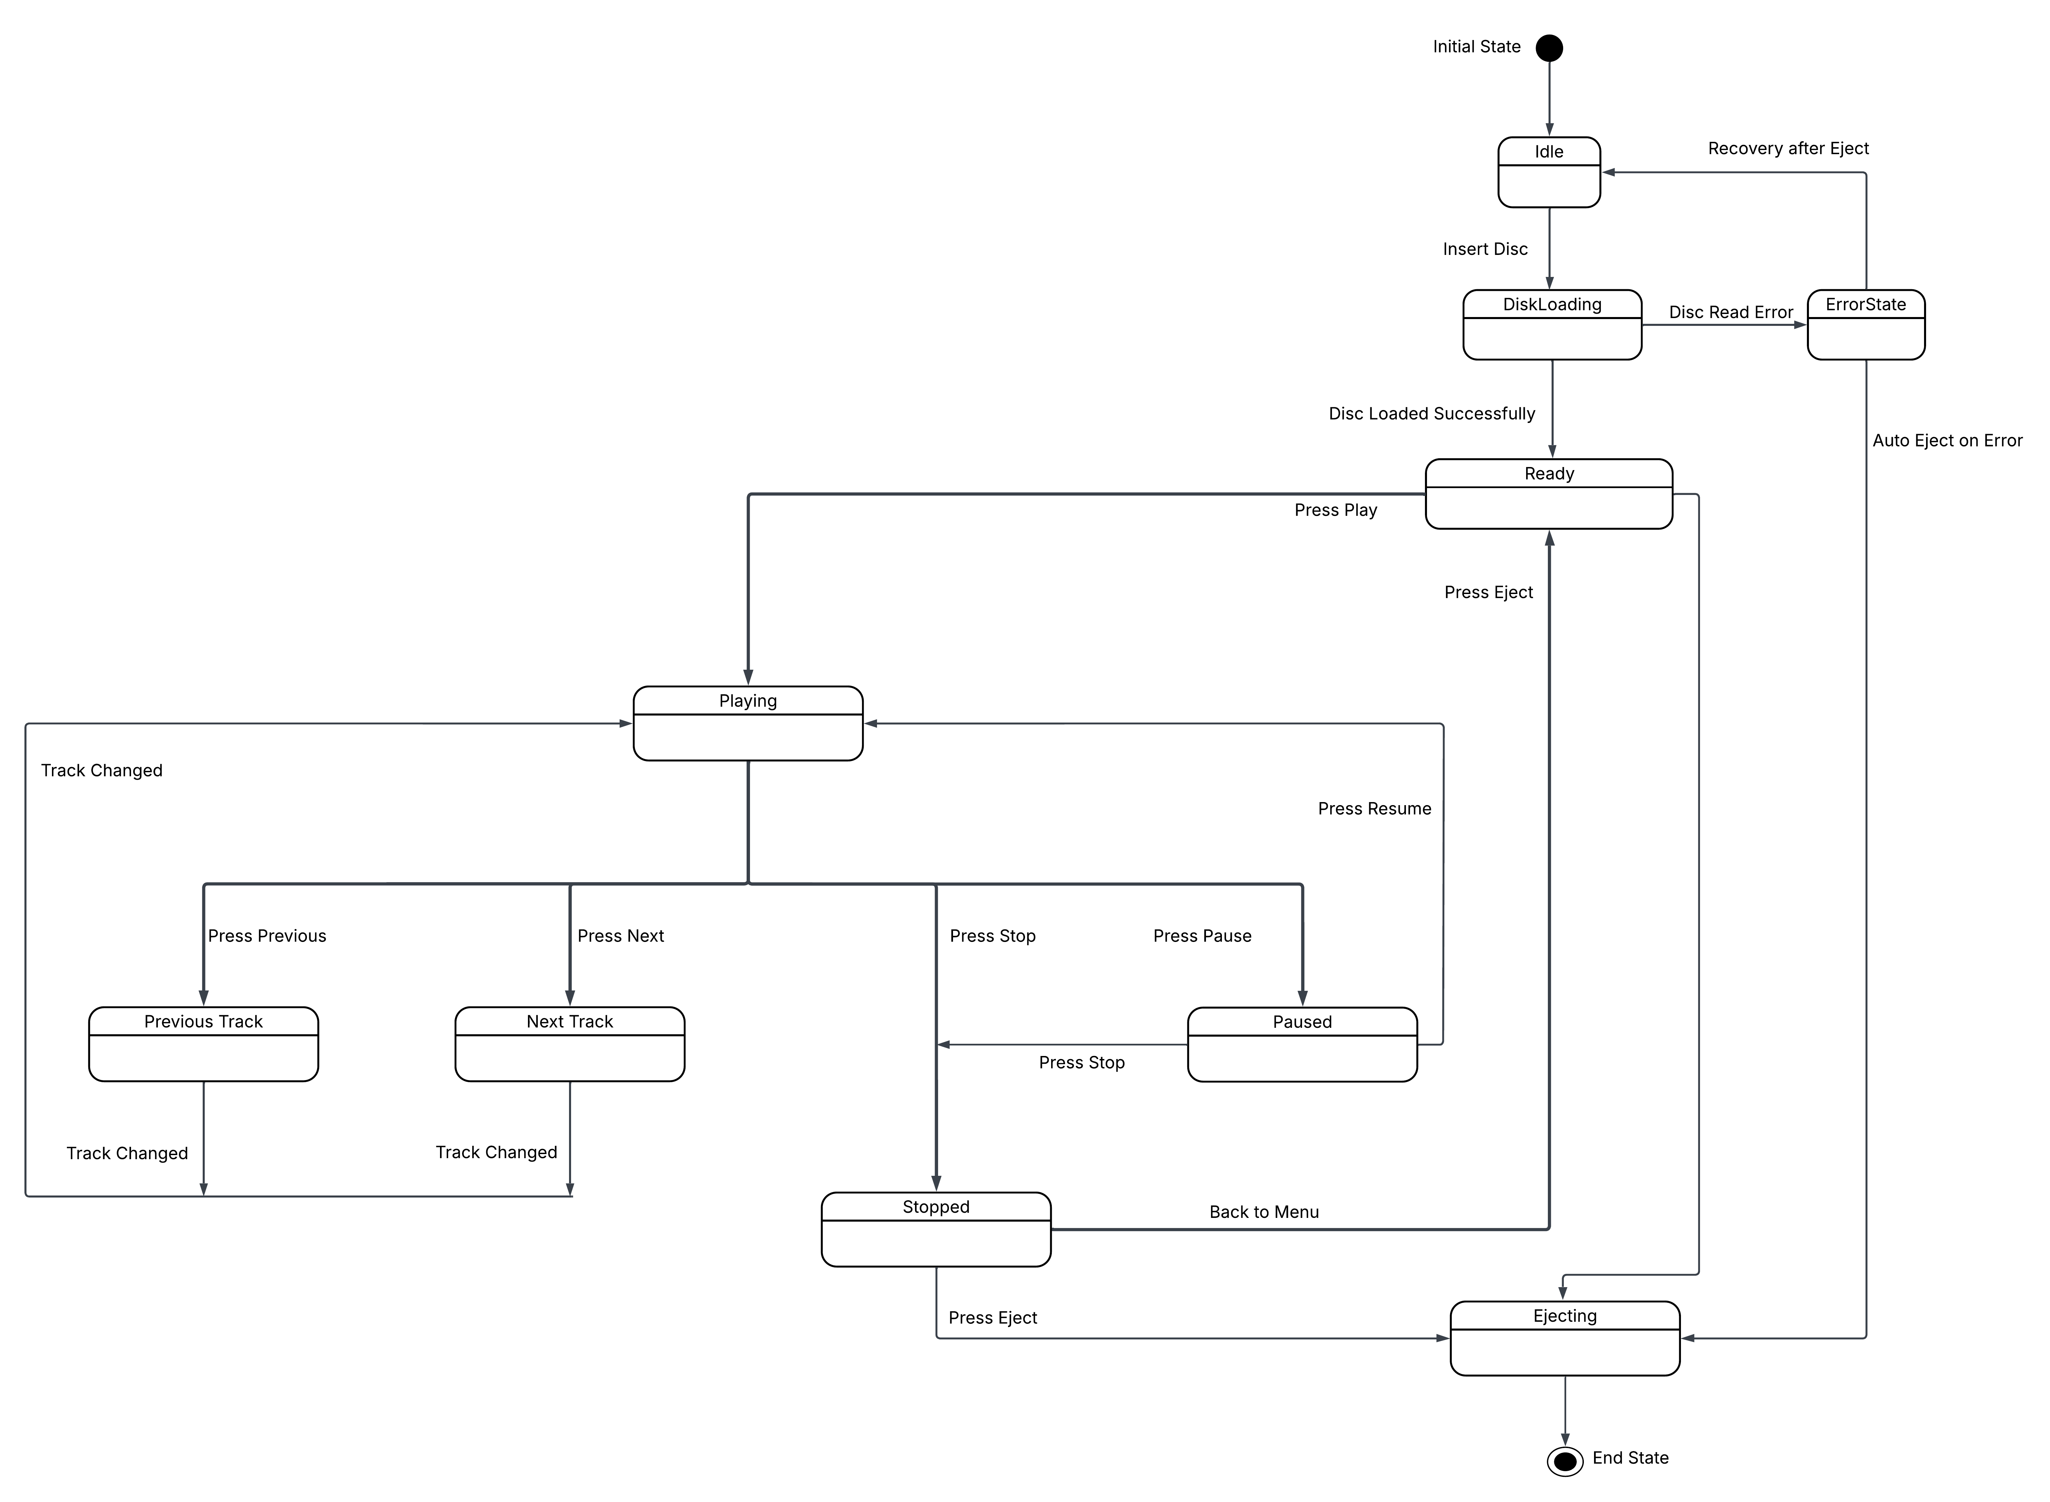

**Explanation:**

**1. Initial State – Idle**

* The system begins in the **Idle** state, which represents the CD player being powered on with no disc inserted.

**2. Disc Handling**

* Insert Disc: When a user inserts a disc, the player transitions from the **Idle** state to **DiskLoading**.
* Successful Load: If the disc is successfully read, the player moves to the **Ready** state, indicating readiness for playback else it moves to **ErrorState** indicating Disc Read Error.

**3. Playback Control**

Once the CD is successfully loaded and the system is in the **Ready** state, the following playback operations are available:

* **From Ready State:**
* Start Playback: The user can initiate playback by pressing the Play button.
* Eject Disc: If the user chooses to remove the disc instead, pressing Eject transitions the system to the **Ejecting** state.
* **During Playback:** While in the Playing state, the user can control playback with the following options:
* Pause Playback: Pressing the Pause button will temporarily halt the playback.
* Resume Playback: From the Paused state, pressing Resume continues playback.
* **Track Navigation:**
* Next Track: The user can navigate to the next track by pressing the Next button.
* Previous Track: Similarly, the user can move to the previous track using the Previous button.
* **Stopping Playback**
* From Playing State: Playback can be stopped directly from the Playing state by pressing the Stop button.
* From Paused State: If paused, playback can also be terminated using the Stop button.

**4. Stop and Menu Navigation**

* After the system enters the **Stopped** state following the stop command, the user has two choices:
* Return to Menu: The player can return to the **Ready** state, allowing the user to select a different track or action.
* Eject Disc: If the user wishes to remove the disc, pressing Eject transitions the system to the **Ejecting** state.

**5. Ejecting the Disc**

* When the user chooses to eject the disc (either from the Ready or Stopped states), the system transitions into the **Ejecting** state:
* This transition indicates that once the disc is physically removed from the player, the system returns to the **Idle** state, ready for a new disc to be inserted.

**6. Error Handling and Recovery**

* The system includes comprehensive error detection at key stages, ensuring robust operation. Specific failure points and their transitions to the Error state are as follows:

|  |  |
| --- | --- |
| **Component** | **Error Transition** |
| DiskLoading | DiskLoading → ErrorState: Disc Read Error |
| Error Handling | ErrorState → Ejecting: Auto Eject on Error |
| Error Recovery | ErrorState → Idle: Recovery after Eject |

**Q3. Draw a detailed state machine models of the control software for: A telephone answering machine which records incoming messages and displays the number of accepted messages on an LED display. The system should allow the telephone owner to dial in, type a sequence of numbers (identified as tones) and have the recorded messages replayed over the phone.**

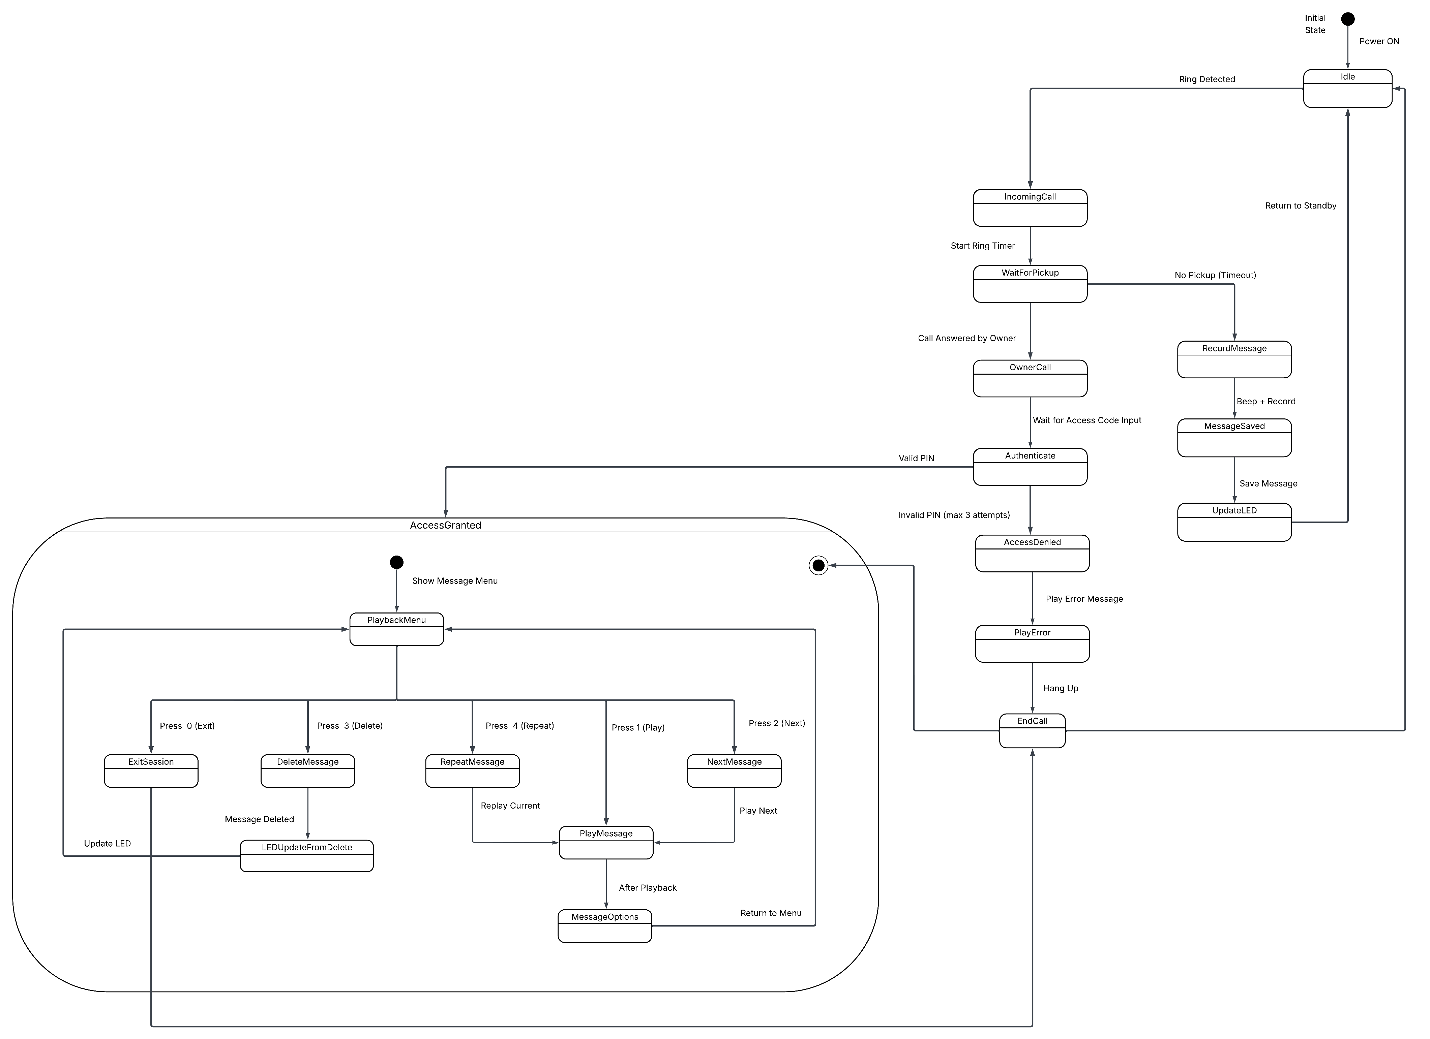

**Explanation:**

**1. Initial State - Idle**

* The system begins in the **Idle** state upon powering on, awaiting either an incoming call or owner interaction.

**2. Incoming Call Handling**

* When a ring is detected, the system transitions from the Idle state to **IncomingCall**, and a ring timer is started to monitor whether the call is answered.

Idle → IncomingCall: Ring Detected

IncomingCall → WaitForPickup: Start Ring Timer

**3. No Pickup**

* If the call is not answered within the specified timeout duration, the system transitions to **RecordMessage** to record the caller’s voice message. After recording, it proceeds to the **MessageSaved** state, where the message is saved, the LED display is updated in the **UpdateLED** state to reflect the new message count, and the system returns to the **Idle** state.

WaitForPickup → RecordMessage: No Pickup (Timeout)

RecordMessage → MessageSaved: Beep + Record

MessageSaved → UpdateLED: Save Message

UpdateLED → Idle: Return to Standby

**4. Owner Picks Up**

* If the call is answered by the telephone owner before the timeout, the system proceeds to the **OwnerCall** state and prompts for a PIN to authenticate the owner:

WaitForPickup → OwnerCall: Call Answered by Owner

OwnerCall → Authenticate: Wait for Access Code Input

**5. Authentication Process**

* If the owner enters an invalid PIN for all three attempts, the system transitions to the **AccessDenied** state, where an error message is played before ending the call and returning to the **Idle** state.

Authenticate → AccessDenied : Invalid PIN (max 3 attempts)

AccessDenied → PlayError : Play Error Message

PlayError → EndCall : Hang Up

EndCall → Idle

* If the owner enters the correct PIN within a maximum of three attempts, access is granted, and the user is transitioned into the **AccessGranted** state for message playback and management session.

Authenticate → AccessGranted: Valid PIN

**6. Owner Session: Playback and Management**

* Once the telephone owner has been successfully authenticated, the system transitions into a composite state called **AccessGranted**, which represents the session in which the owner can interact with the stored messages. During this session, the owner is presented with a **PlaybackMenu**, where message management options are available via DTMF (Dual-Tone Multi-Frequency) tones entered through the telephone keypad.

The options available in the **PlaybackMenu** are:

* Press 1: Play the current message.
* Press 2: Move to the next message.
* Press 3: Delete the current message.
* Press 4: Repeat the current message.
* Press 0: Exit the session.

Each of these inputs triggers a specific transition within the system:

* From the initial sub-state, the system enters the **PlaybackMenu**.
* Pressing 1 transitions the system to **PlayMessage**.
* Pressing 2 transitions the system to **NextMessage**.
* Pressing 3 transitions the system to **DeleteMessage**.
* Pressing 4 transitions the system to **RepeatMessage**.
* Pressing 0 transitions the system to **ExitSession**.
* After a message has been played, the system provides further options through the **MessageOptions** state, allowing the user to return to the main menu for further actions.
* If the user chooses to delete a message, the system transitions to the **LEDUpdateFromDelete** state, where the LED display is updated to reflect the change in message count. After this, the system returns to the **PlaybackMenu**.
* Once the user presses 0 to **exit** the session, the system moves to the **EndCall** state, exits the composite state, and finally returns to the **Idle** state, indicating that the session has been concluded.